Practice for topics 2 – 5 and 2 – 6: Linear motion and creating your own parameterizations

1). [P/C]
a). I want to define a linear path for a point which starts at (2, 5) at t = 0 and moves at a constant speed to end at (8, 15) at t = 1. Give a set of parametric equations which describe this path and movement.
b). Give $x(t)$ and $y(t)$ equations for this same path, but so that the point starts at (2, 5) at $t=0$ and moves faster than your equations for part a.
c). Modify your equations from part a so that the point is at (2, 5) at $t=3$ and ends at (8,15) at $t=4$.
d). Now give a pair of parametric equations for the reverse motion of part a. It should start at (8, 15) at t = 0 and end at (2, 5) at t = 1.

2). [P] Write your own piecewise defined functions for x(t) and y(t) so that from t = 0 to t = 5 a point travels from (1, 2) to (3, 4), and from t = 5 to t = 10, the point travels from (3, 4) to (0, 0).

3). [P] If $x\left(t\right)=2t+1$ , what does $y(t)$ have to be so the path defined by the equation is $y=x+\frac{1}{x}$ ?

4). [P]
a). In your solution to problem 3, the point is at (1, 2) at t = 0 and moves to the right. How do you know each of those facts are true?
b). Create another parameterization of $y=x+\frac{1}{x}$ so the point starts at $\left(2, 2.5\right)$ when t = 0 and moves left (as time increases).

5. [P] In this problem you’ll make 3 different parameterizations of $y=\sqrt{x}$
a). If $x\left(t\right)=10-t$ where does the point start at t = 0 and what direction does it move as t increases?
b). Find $y(t)$ so that the point moves along the path $y=\sqrt{x}$
c). Find x(t) and y(t) so that the point moves along $y=\sqrt{x}$ but starts at (4, 2) when t = 0 and moves to the right.
d). Find another x(t) and y(t) so that the point moves along $y=\sqrt{x}$, starts at $(4,-2)$ when t = 0 and moves right faster than part c.

6. [P] If $x\left(t\right)=t^{2}-3$ what $y(t)$ will make the point move along the path $y=-2{\left(x-3\right)}^{2}+4$
7. [P] Consider these parametric equations: $x(t)=t^{2}-3$ and $y\left(t\right)=3t^{2}$
a). Your friend thinks these define motion along a parabolic path. Convince them that they’re wrong. What is the shape of the path?
b). If $x\left(t\right)=t^{2}-3$ , what $y(t)$ would make the motion be along the path $y=x^{2}$ ?
c). At what time is the point at the vertex of the parabola (for your equations in part b).
d). What’s the domain of the path actually travelled? Put the other way, what part of the parabola $y=x^{2}$ won’t ever be touched by the point as it moves.

8. [P]
a). Make a parameterization of $y=x^{2}$ so that your point is at $\left(10, 100\right)$ at time t = 0, and at $(12, 144)$ at time t = 10.
b). Find the reverse: start at (12, 144) at t = 0 and move to (10, 100) at t = 10 (still along $y=x^{2}$).

9). [P] I want to hit x = 10 at t = 3 and x = 20 at t = 5.
a). Create a linear x(t) which will let me hit those coordinates at the right times. (notice, no $y(t)$ … we just want to describe horizontal movement). This gives a constant horizontal speed.
b). Create a quadratic x(t) which will hit those points at those times. This gives an accelerating horizontal speed.

*10). [P] Find $x(t)$ and $y(t)$ equations so a point will move back and forth along $y=x^{2}$. Specifically, at t = 0 it should start at (0, 0). At t = 5 it should reach (10, 100), turn around, and reach (0, 0) again by t = 10.
Do this without using a piecewise defined function.

Solutions – Topic 2 – 5 and 2 – 6: Linear motion and creating your own parameterizations
1). [P]
a). I want to define a linear path for a point which starts at (2, 5) at t = 0 and moves at a constant speed to end at (8, 15) at t = 1. Give a set of parametric equations which describe this path and movement.
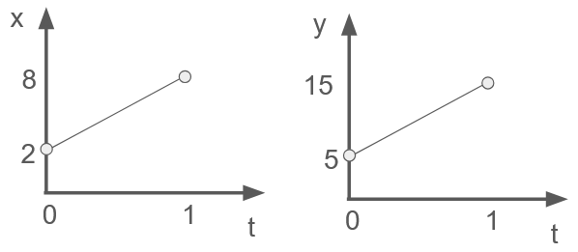
An easy way to do this is sketch graphs for $x(t)$ and $y(t)$, then write the equations for your graphs.
$$x\left(t\right)=6t+2$$
$$y\left(t\right)=10t+5$$

Notice I didn’t even try and match the scales of my graphs since it doesn’t matter! The graphs are just there as a thinking tool to make it easier for me to write the linear equations.

b). Give $x(t)$ and $y(t)$ equations for this same path, but so that the point starts at (2, 5) at $t=0$ and moves faster than your equations for part a.
If it’s going to move faster along the same path, that means it must reach (8, 15) before $t=1$. One thing you could do is just decide on a time, like $t=\frac{1}{2}$ and make two new graphs like those above to get your equations.
A different approach would be to scale the time variable. If I want 0 to 0.5 seconds to act like the original interval 0 to 1 seconds, I need to stretch time by a factor of 2 before inputting it to $x(t)$ and $y(t)$.
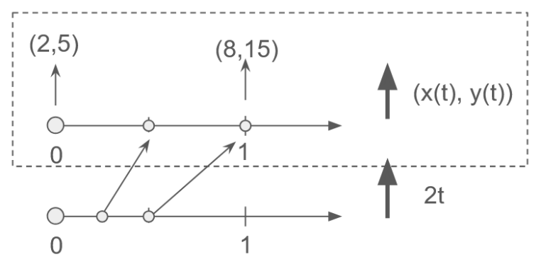
In other words, I want $x(2t)$ and $y\left(2t\right).$ The diagram to the left is how I think about it in my mind.
Inside the dashed box, you see that $x(t)$ and $y(t)$ map 0 to (2,5) and 1 to (8,15).
I wish that $\frac{1}{2}$ got mapped to (8, 15). So if I double the time input before sending it through $x(t)$ and $y(t)$ it will do that.
Algebraically: $x\left(2t\right)$ is $6\left(2t\right)+2$ which is $x\left(t\right)=12t+2$. $y(2t)$ is $10\left(2t\right)+5$ which is $y\left(t\right)=20t+5$.
That gives: $x\left(t\right)=12t+2$ and $y\left(t\right)=20t+5$. You can see that $\left(x\left(\frac{1}{2}\right), y\left(\frac{1}{2}\right)\right)$ will be $(8,15)$ as desired.
c). Modify your equations from part a so that the point is at (2, 5) at $t=3$ and ends at (8,15) at $t=4$.
As before, you can draw two new graphs and get the equations from there. A little nice is to be able to imagine how you need to shift time so your original equations will apply to the new times.
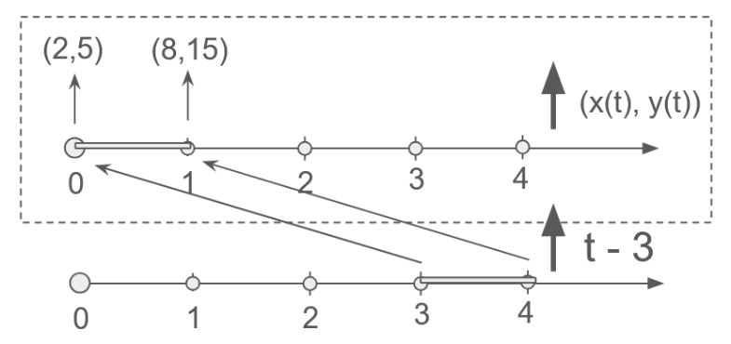
Here’s the picture in my head. I want t = 3 to act like t = 0, and t = 4 to act like t = 1. So I need to shift time back by 3 before I send it as input to $x(t)$ and $y(t)$.
As an equation, that means I’ll be plugging in $t-3$ as the t value to my $x(t)$ and $y(t)$ equations.

Here’s how it looks algebraically.
Original: Time shifted:
$x\left(t\right)=6t+2$ $x\left(t\right)=6(t-3)+2$
$y\left(t\right)=10t+5$ $y\left(t\right)=10(t-3)+5$

You can see that plugging $t=3$ in to the time shifted equation is like plugging t = 0 into the original.

d). Now give a pair of parametric equations for the reverse motion of part a. It should start at (8, 15) at t = 0 and end at (2, 5) at t = 1.
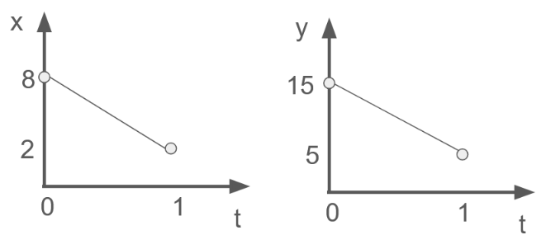
This one is probably best solved by drawing two new graphs and getting your equations from there, like this.
$$x\left(t\right)=8-6t$$
$$y\left(t\right)=15-10t$$

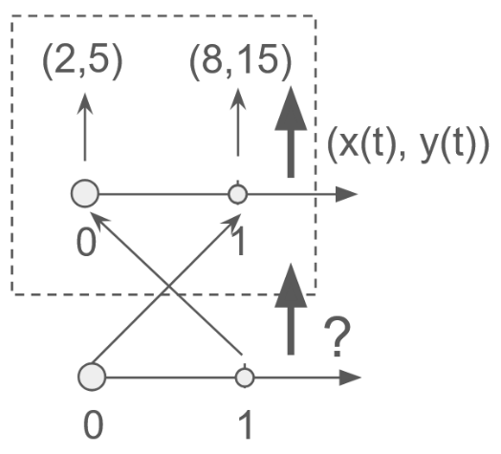
You could think about how to transform time before sending it as input to the original function, but the transformation is slightly harder to think about. Before if I wanted to stretch time I could use $2t$. When I wanted to shift time, I could use $t-3$. What’s an equation that describes this mapping of 0 to 1 and 1 to 0?
A nice way to think of it is as a reflection around $\frac{1}{2}$ .
One way to get this reflection is to do the following in order:
Shift left by $\frac{1}{2}$, reflect around 0, shift right by $\frac{1}{2}$
Algebraically this looks like: $-\left(t-\frac{1}{2}\right)+\frac{1}{2}$
Note that if $t=1$ this will output 0. If $t=0$ this will output $1$.
Algebraically, you’d plug $-\left(t-\frac{1}{2}\right)+\frac{1}{2}$ into the original $x(t)$ and $y(t)$ equations. That will give you the same solution as the one above.
2). [P] Write your own piecewise defined functions for x(t) and y(t) so that from t = 0 to t = 5 a point travels from (1, 2) to (3, 4), and from t = 5 to t = 10, the point travels from (3, 4) to (0, 0). **** fix this ****
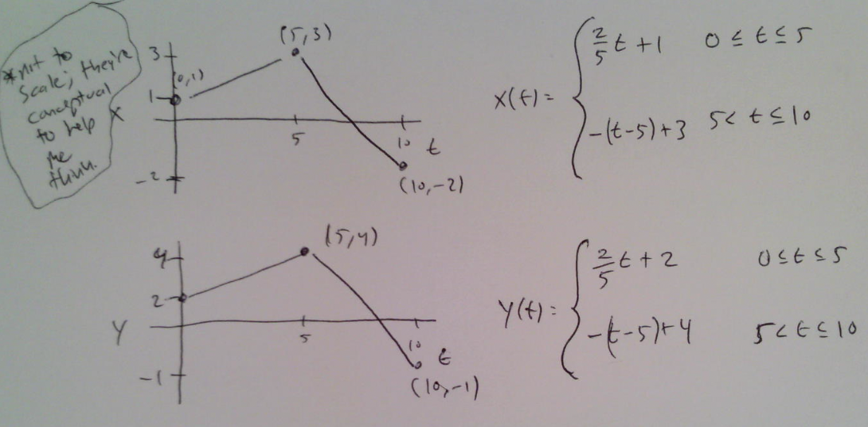

3). If $x\left(t\right)=2t+1$ , what does $y(t)$ have to be so the path defined by the equation is $y=x+\frac{1}{x}$ ?
Remember that $x(t)$ is the function that represents x. $y(t)$ is the function that represents y. That means if you want to think about x as a function, you can write $y=x+\frac{1}{x}$ as $y=x\left(t\right)+\frac{1}{x(t)}$. But you know what $x(t)$ is, so substitute it: $y=\left(2t+1\right)+\frac{1}{2t + 1}$

4). [P]
a). In your solution to problem 3, the point is at (1, 2) at t = 0 and moves to the right. How do you know each of those facts are true?
At $t=0$ $x\left(0\right)=2⋅0+1=1$. If you plug $1$ into $y=x+\frac{1}{x}$ you get $y=1+\frac{1}{1}=2$. That’s how I know $t=0$ starts at $\left(1,2\right)$. I know the point moves right because as $t$ increases, $x\left(t\right)=2t+1$ also increases.
b). Create another parameterization of $y=x+\frac{1}{x}$ so the point starts at $\left(2, 2.5\right)$ when t = 0 and moves left (as time increases).
All I really care about is when t = 0 making x = 2. If I do that, then the y-value will automatically by 2.5 (just imagine plugging $x=2$ into the path equation $y=x+\frac{1}{x}$ ).
SO … let’s imagine a graph. This does all the things I need: at $t=0$ x will be 2, and as time increases, x is decreasing, meaning the point will be moving left.
An equation could be $x\left(t\right)=2-t$
…therefore $x\left(t\right)=2-t$ and $y\left(t\right)=2-t+\frac{1}{2-t}$
This isn’t the only solution. $x\left(t\right)=2-10t$ and $y\left(t\right)=2-10t+\frac{1}{2-10t}$ also works. Or $x\left(t\right)=2-t^{10}$ and $y=2-t^{10}+\frac{1}{2-t^{10}}$ .

5). In this problem you’ll make 3 different parameterizations of $y=\sqrt{x}$
a). If $x\left(t\right)=10-t$ where does the point start at t = 0 and what direction does it move as t increases?
At x = 10. As time increases, the point moves left. Check a few times and x-values in a table to verify.

b). Find $y(t)$ so that the point moves along the path $y=\sqrt{x}$
$y\left(t\right)=\sqrt{10-t}$ . All I did was took the square root of the x equation.

c). Find x(t) and y(t) so that the point moves along $y=\sqrt{x}$ but starts at (4, 2) when t = 0 and moves to the right.
Let’s choose an x(t) function that does what we want. If $x\left(t\right)=t+4$ I know that $x\left(0\right)=4$ as desired. I also know that as t increases, so will the x-coordiantes. To make the y-coordinate correct, I ensure that it follows the $y=\sqrt{x}$ path: $y\left(t\right)=\sqrt{t+4}$

d). Find another x(t) and y(t) so that the point moves along $y=\sqrt{x}$, starts at $(4,-2)$ when t = 0 and moves right faster than part c.
$x\left(t\right)=5t+4$ and $y\left(t\right)=\sqrt{5t+4}$

6). [P] If $x\left(t\right)=t^{2}-3$ what $y(t)$ will make the point move along the path $y=-2{\left(x-3\right)}^{2}+4$
We just substitute the x(t) equation into the y-equation: $y\left(t\right)=-2{\left(\left(t^{2}-3\right)-3\right)}^{2}+4=-2{\left(t^{2}-6\right)}^{2}+4$

7). Consider these parametric equations: $x(t)=t^{2}-3$ and $y\left(t\right)=3t^{2}$
a). Your friend thinks these define motion along a parabolic path. Convince them that they’re wrong. What is the shape of the path?
You could plug in some times and show that y and x don’t have the relationship of a parabola. A better answer might be to actually find the equation of the path. Let’s do this by eliminating t.
$x=t^{2}-3$ $x-3=t^{2}$ Now I’ll substitute in for $t^{2}$ in the y-equation. $y=3\left(x-3\right)$.
So you see it’s a linear path.
Conceptually, x increases quadratically with t, but y also increases quadratically with t. So y and x must have a linear relationship to each other.
b). If $x\left(t\right)=t^{2}-3$ , what $y(t)$ would make the motion be along the path $y=x^{2}$ ?
I know $y=x^{2}$ so $y\left(t\right)={\left(x\left(t\right)\right)}^{2}$ or $y\left(t\right)={\left(t^{2}-3\right)}^{2}$
c). At what time is the point at the vertex of the parabola?
I know the vertex of $y=x^{2}$ is at (0, 0). So let’s solve for the time when x = 0. $0=t^{2}-3$ . So there are actually two times: $t=\sqrt{3}$ and $t=-\sqrt{3}$. We know that both those time will also make a y-value of 0 because our $y(t)$ equation was made specifically to fit $y=x^{2}$, so if $x=0$ y will also be 0.
d). What’s the domain of the path actually travelled? Put the other way, what part of the parabola $y=x^{2}$ won’t ever be touched by the point as it moves.

8. a). Make a parameterization of $y=x^{2}$ so that your point is at $\left(10, 100\right)$ at time t = 0, and at $(12, 144)$ at time t = 10.
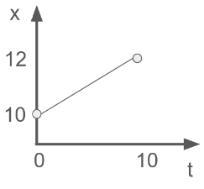
[hint: use a table or graph to think about what you want x(t) to do].

Here I just wrote down the information I wanted: at t = 0 x should be 10, and t = 10, x should be 12. Then I wrote a linear equation, meaning that the x-coordinates will change at a constant rate from 10 to 12 over 10 seconds.

To make it follow the path $y=x^{2}$ I’ll just set my $y(t)$ accordingly:

$$x\left(t\right)=\frac{1}{5}t+10 y\left(t\right)={\left(\frac{1}{5}t+10\right)}^{2}$$

b). Find the reverse: start at (12, 144) at t = 0 and move to (10, 100) at t = 10 (still along $y=x^{2}$)

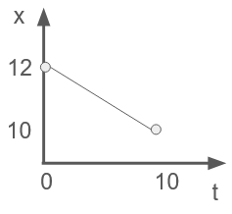
Making another graph, I see that $x\left(t\right)=-\frac{1}{5}t+12$
So $y\left(t\right)={\left(-\frac{1}{5}t+12\right)}^{2}$

9). [P] I want to hit x = 10 at t = 3 and x = 20 at t = 5.
a). Create a linear x(t) which will let me hit those coordinates at the right times. This gives a constant horizontal speed.

$$x\left(t\right)=5\left(t-3\right)+10$$

b). Create a quadratic x(t) which will hit those points at those times. This gives an accelerating horizontal speed.

We know we want to points on the parabola: (3, 10) and (5, 20).

There are an infinite number of parabolas that go through those two points, but let’s choose an easy one: let’s make (3, 10) be the vertex of an upward facing parabola. Plot the points to visualize what I’m saying.

This gives: x = $k{\left(t-3\right)}^{2}+10$ now all I need is to solve for the scale-factor k that will send it through the point (5, 20).

Doing so gives me: $x\left(t\right)=\frac{5}{2}{\left(t-3\right)}^{2}+10$

*10). [P] Find $x(t)$ and $y(t)$ equations so a point will move along $y=x^{2}$.
At t = 0 it should start at (0, 0). At t = 5 it should reach (10, 100), turn around, and reach (0, 0) again by t = 10.
Do not use a piecewise defined function.

There are 3 points we want on our x(t) curve: (0, 0), (5, 10), and (10, 0). Plot these. How can we make a curve that connects them all? Easy; let’s just make it a parabola.

Let’s make (5, 10) be the vertex of a downward facing parabola and solve for a missing scale factor.

Doing so gives:
$$x\left(t\right)=-\frac{10}{25}{\left(t-5\right)}^{2}+10$$

It was lucky for us that the 3 points were evenly spaced to allow this. Otherwise it would have been harder to fit the parabola to the 3 points.

Now we can use that in $y=x^{2}$ to find the $y(t)$ equation.

$x\left(t\right)=-\frac{10}{25}{\left(t-5\right)}^{2}+10$ and $y\left(t\right)={\left(-\frac{10}{25}{\left(t-5\right)}^{2}+10 \right)}^{2}$

